White Paper
Draft v1.0
Where has all the growth in data-traffic gone?
The data centre industry has long talked about a ‘tsunami’ of data traffic that has driven growth in data centre facilities, and, in the early years of the internet, that was certainly true.
Luckily we have had, since 2001, a 100% reliable source of historical monthly data traffic volume within our grasp, without paying for nebulous market reports, or depending on rumours and opinions – one of the major internet exchanges of Europe, AMS-iX.
The internet exchanges are not data centres per se, although in many respects they look like one, but they are where the international fibre backbones and national fibre networks are connected and ‘meet’. Each country has one major exchange, usually in its most mature data hub, for example in London, Frankfurt, Paris, and Amsterdam.
I have been monitoring the traffic data of AMS-iX (the Amsterdam exchange) from 2001-to-date, each month updating a spreadsheet I constructed in 2022, for no better reason than free access and their on-line archive, at https://stats.ams-ix.net/historical.html. This white paper is based on the ‘Total Input’ and separately ‘Total output’, of TB/s over 24h and TB/month, but the conclusions are all mine.
One aspect that I rely on, and one that I invite the reader to challenge, is that Amsterdam, with its pivotal role in trans-Atlantic fibre connection and large data centre estate, is a good proxy for pan-European traffic. Its continuous archive since 2001 heavily influences my trust and opinion.
However, in the few years since the onset of the Covid outbreak, there has been two data-traffic ‘contenders’ that were expected to drive significant growth, namely during the Covid lockdown and its ‘working from home on Zoom’ syndrome and, after that, the rise of everything that included ‘AI’ in its title. This paper will show that the Covid-effect can be clearly demonstrated, but challenge the notion that the rise of AI has started, or is it yet to transpire?
I have split my paper into the timelines:
- 2001-2019 – the rise of the internet,
- 2020-2021 – the Covid years, and
- 2022-date – the rise of AI
In each case I will look at examples of the traffic flow in Tb/s over 24h, the profile of which is something that is very surprisingly stable over many years, and leads to one major conclusion.
But, before that, there is one question to explore: Can we use data traffic as a proxy for power demand?
On any given day, hourly over 24h, it is possible to use data traffic as a direct proxy for power demand in the data centre estate; when the traffic goes up, data centre power goes up and vice versa. But over a relatively short timeframe of a few months the impact of Moore’s Law (and its derivatives such as Koomey’s Law) has to be taken into account. The simple fact is that every new generation of microprocessor can handle more computations per Watt than the last. This was originally predicted by Gordon Moore (one of the founders of Intel) to be a doubling of transistors on one processor every two years, reduced to 18 months by Koomey, and later to 14 months by Ray Kurzweil.
The fact remains that the ICT hardware, both computation and storage, has historically beaten all predictions of capacity/Watt and Fig 1 illustrates a point-in-time when the hardware performance trajectory started to overtake the data traffic demand.
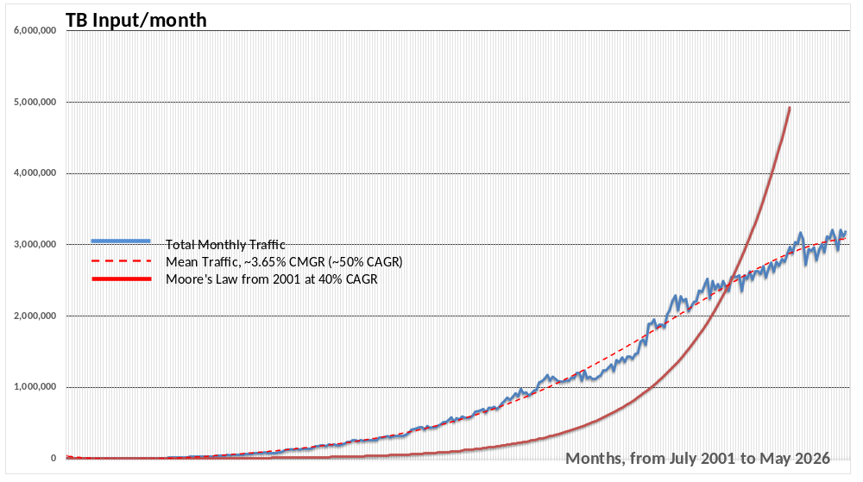There are many anecdotal examples of data centre ‘expansion plans’ that have ignored the effect of Moore’s/Koomey’s Laws and have overprovisioned space, power, and cooling for a load that has never been realised. Example: CSFB built three 8MW data centres, designed in 2001-2 when data growth was 80% per year and rising rapidly, that were by 2017 ever loaded higher than 2MW due to ICT hardware refresh rates and the fact that their business was not related to images/video but numbers.
Figure 1 The growth in data throughput compared with Moore’s Law (40%CAGR) capacity/Watt curve, 2001-date
Data traffic as a proxy for power demand?
The fact remains that the ICT hardware, both computation and storage, has historically beaten all predictions of capacity/Watt and Fig 1 illustrates a point-in-time when the hardware performance curve started to overtake the data traffic curve. Both curves are exponential, but at different R values.

2001 to 2019 – the Internet years
The growth years for the period leading up to the Covid were characterised by a steadily reducing exponential rate.
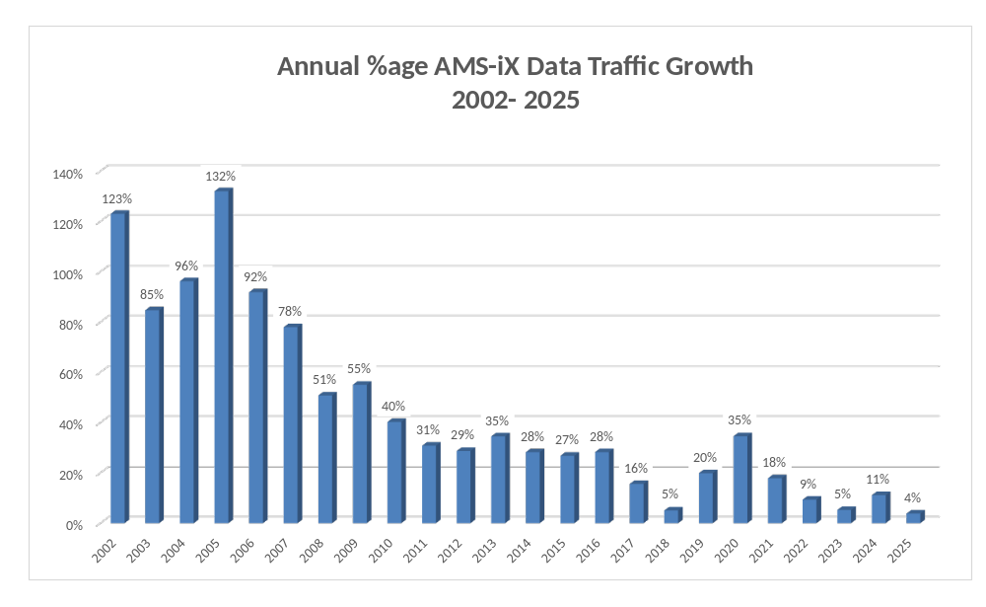
Figure 2 High growth rate, with a declining R
When AMS-IX data recording started in June 2001 the traffic for the month was 690TB, but by December 2019 it had risen to 1,640,000TB, 2,377 times the volume.
The annual traffic profile was always backend-loaded with higher growth in the second half of the year, see Figure 3, e.g., with Dec 2019 contributing half of the 20% annual rate. I cannot attribute anything of 2019 to Covid, nor have I any explanation as to why 2018 was low, other than pointing out that a 5% growth rate is a figure that many non-ICT businesses might be happy with.
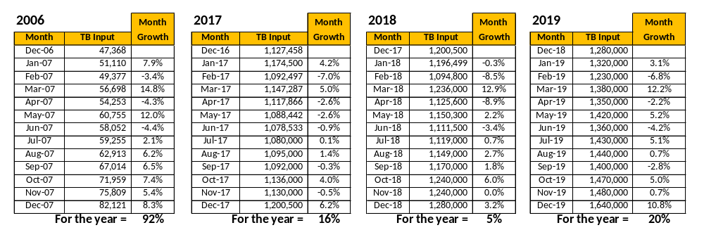
Figure 3 Monthly comparisons of various years
The growth rate for 2001-2010 exceeded any derivation of Moore’s Law, so demand for ICT hardware was highly positive.
One very interesting aspect of these years is the profile in traffic over every 24h period and Figure 4 shows this clearly. I have taken an example from 2016, deliberately during a high growth-rate period and without any Covid-effect.
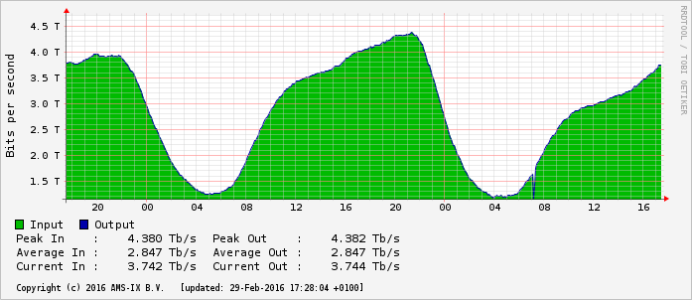
Figure 4 TB/s traffic by time-of-day (29th Feb 2016)
Bits per second (input and output curves are fully synchronised) falling to a minimum at 4:30am (CET) at around 1.3TB/s and rising to a maximum at 9:30pm (CET) at around 4.2TB/s – always, every day, regardless of day of the week, weekends, public holidays, and seasons.
New records for peak traffic rates are set every year, but as a general example, in this 2016 example it peaked at 4.4TB/s, compared to 10 years later at 13.9TB/s (June 2026).
Conclusions for 2001-2019
The only conclusion that I can suggest is that this traffic was dominated by video, consumed at home; on-line gaming, internet-shopping, internet-TV services, social media and video-calling, and probably high definition pornography. It does not appear to be ‘business’ traffic that is not related to video.
Nowhere in this internet traffic story so far supports the regular ‘Tsunami of data’ press items of our industry and I don’t recall any investment alarms going off when the growth dramatically fell during 2017-18. Or did I miss something?

2020 to 2021 – the Covid-19 years
When Covid-19 struck and we (medical and care staff excluded) were forced into lockdown, the long-vaulted promise of working remotely on-line with video conferencing came into its own.
Although a lot of fuss about the internet ‘straining under the pressure’ was made in the first couple of weeks it was very quickly resolved by the system opening up dark fibre and extending connectivity contracts. At home, families with teenagers added ‘multi-room’ to their satellite TV streaming contracts and beefed up their broadband connectivity.
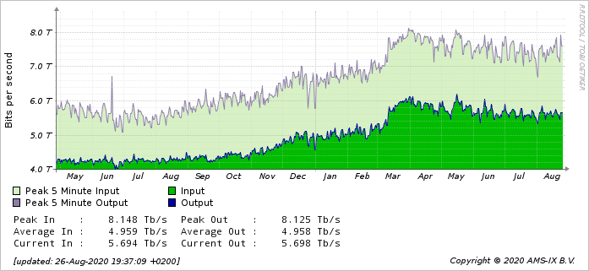
Figure 5 The Bits/second Covid-19 jump in March 2020
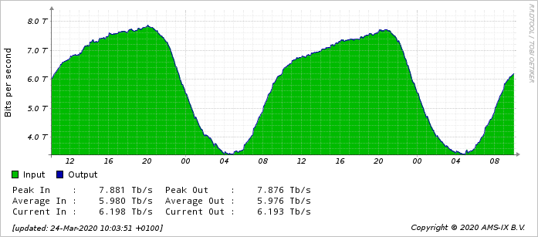
In the year leading to Covid-19, up to Sept 2019 (as in many prior years) the traffic had shown very low growth, with the last quarter Oct-Dec showing the usual burst. Having reached an average 5.2TB/s in December the traffic plateaued again until the first Covid lockdown struck in March 2020, and Figure 5 shows the 20% jump in Bits/s, from circa 5TB/s to 6TB/s. The 20% figure was widely reported as ‘working-from-home on Zoom’ but Figure 6 tells the same story as before: By 04:30 (CET) users (teenagers?) were exhausted and the traffic slumped, and the peak volume was hit at 21:00 (CET), all outside of normal working hours.
Figure 6 Traffic over 24h, 24th March 2020

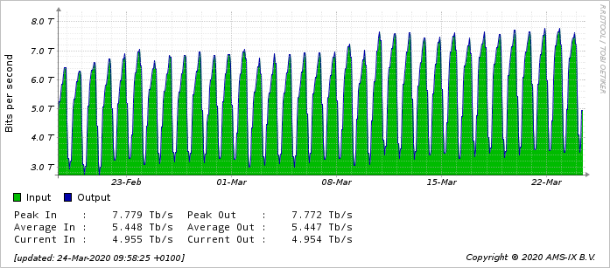
Figure 7 23rd Feb to 22nd March daily TBits/s
And, just to reinforce the regularity of the daily profile, Figure 7 shows the jump on the 11th March, with both the daily trough and peak.
Conclusions
The first lockdown showed a 20% step in traffic demand that affected the entire 24h profile, not just during normal working hours. It is more than possible that families with children of school and university age contributed as much to the demand for internet services as those workers who were sent home to work on-line.

2022 to May 2026 – the rise of AI
The purpose of writing this paper was to look at the impact that AI Training and/or Inference is making on European network traffic.
The unprecedented investment in AI training facilities has been focussed on the GW-Class of GPU clusters trying to emulate the neural network and cortex of the (singular) human brain and the scale of the facilities (concentrated in single locations to enable the paralleling of communication at close to light speed (in fibre). The “race to AI” started at 30MW test instances, quickly moving to 300MW, then 1GW, and then almost immediately, to 3GW and has been, so far, centred entirely in the USA. The realisation of the capacity/speed limits placed on the emulation using GPUs (rather than quantum or more futuristic biological) may have to be 5-8GW to ‘win’ and monetize the result, has created a feeding frenzy with facilities immediately being announced off-grid, gas fuelled, or nuclear.
None of these GW-class facilities have opened at full scale and only one has been started in Eurupe, announced to be 1.2GW in Portugal, a grid with a National grid summer load of 2GW. The hype is parabolic and it is difficult to determine likely completion dates or even success. A GW load involves an infrastructure in the European context of 3-4 years just for power provision.
So, AI-Training is unlikely to have impacted European data traffic, and Figure 8 entirely supports that view – with a never-before-seen annual growth rate of only 3.8% for 2025.
Figure 8 Annual Data Growth rates 2002-to-Dec 2025
What about monthly traffic pre and post Covid?
Figure 9 illustrates an interesting inflexion where a 40%CAGR curve, e.g., Moore’s Law, the red line, that started in 2001 finally pulled ahead of the data traffic around Feb 2024. In theory this could indicate the point where ICT hardware starts to need refreshing less often.
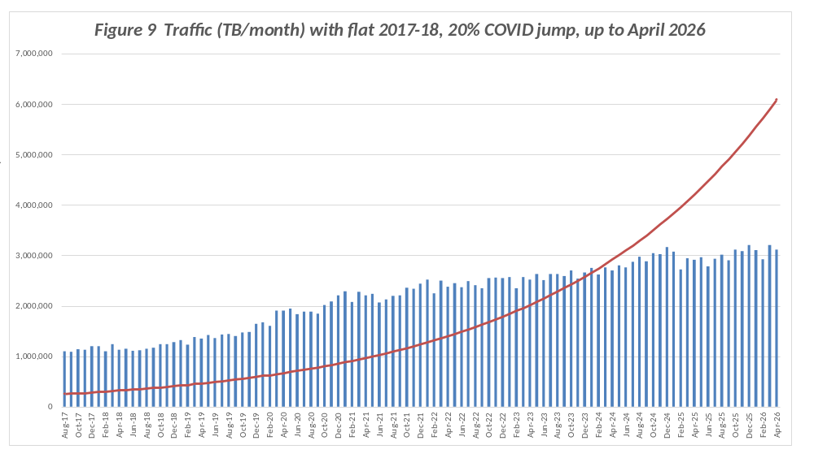
After Dec 2025 the AMS-iX Internet Exchange traffic has plateaued around 3.1EB/month to May.

And who is using the internet?
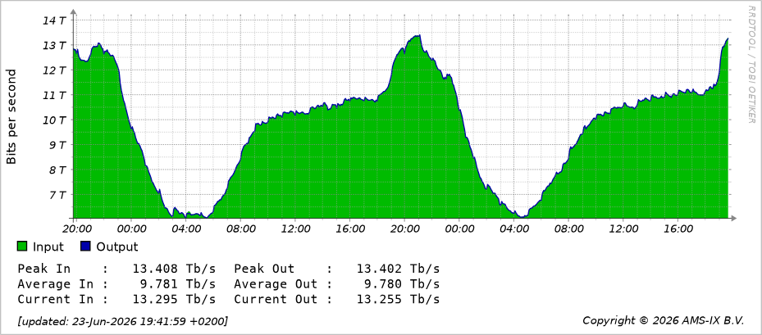
Figure 10 TB/s Traffic over 24h, 23rd June 2026
It should by now be no surprise that the trough is at 04:00 CET (6TB/s) and peak is at 21:00 CET (13.4TB/s) – driven by domestic consumption.
Conclusions for the AI-era, 2022-2026
Immediately we have to ask about AI-Inference? Is anyone using AI at scale? Are we just using free-to-use AI tools to produce manipulated images for fun? Are business users finally paying for tokens on a scale that will justify the massive investment? It looks like the AI-bubble has neither turned up, and certainly not burst.
There is no obvious proof from the European network traffic that any surge attributable to the use of AI is happening, yet.

Ian Bitterlin
DCA Member
23rd June 2026

Prof Jonathan Koomey described the trend 2010: For about a half-century, the number of computations per joule of energy dissipated doubled every 1.57 years. This trend had been stable since the 1950s, but in 2011, Koomey re-examined this data and found that after 2000, the doubling slowed to about once every 2.6 years. This is related to the triple effect of a slowing of Moore's law, the ability to build smaller transistors, and the end of Dennard scaling (the ability to build smaller transistors with constant power density). (Source: Précis from Wikipedia)

